Financial Statements
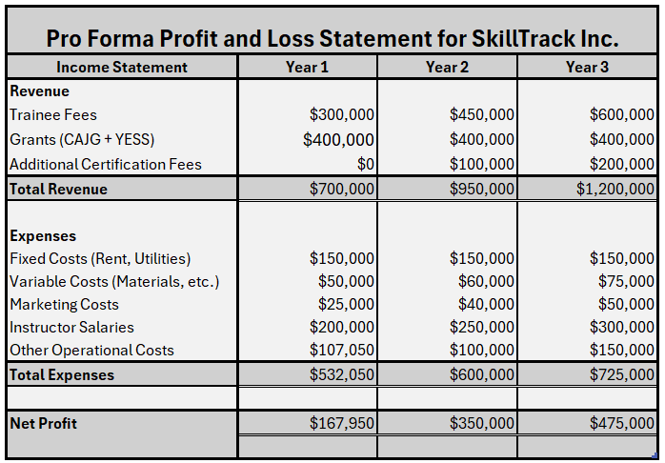
Note. The Profit and Loss statement for SkillTrack developed using hypothetical figures. From Author.

Pro Forma Profit and Loss Statement
The Profit and Loss Statement provides a forecast of SkillTrack Inc.’s financial performance over three years. The key components are as follows:
- Revenue:
- Trainee Fees: SkillTrack’s core revenue driver is the MB800 Microsoft Dynamics course, priced at $3,000 per trainee. In Year 1, we expect 100 trainees, increasing to 150 in Year 2 and 200 in Year 3 as marketing efforts and brand recognition improve.
- Grants: SkillTrack will benefit from $400,000 in grants annually through the Canada-Alberta Job Grant (CAJG) and Youth Employment and Skills Strategy (YESS) programs.
- Additional Certification Fees: Starting in Year 2, SkillTrack will introduce advanced certification programs and corporate training packages, projected to generate $100,000 in the second year and $200,000 by the third.
- Expenses:
- Fixed Costs include rent, utilities, and salaries for staff, estimated at $150,000 annually.
- Variable Costs will increase as enrollment grows, starting from $50,000 in Year 1 and rising to $75,000 by Year 3. These include course materials and equipment.
- Marketing Costs will expand alongside growth efforts, rising from $25,000 in Year 1 to $50,000 by Year 3.
- Instructor Salaries reflect the scaling of operations, starting at $200,000 in Year 1 and reaching $300,000 in Year 3.
- Other operational costs, such as administrative and technology-related expenses, are expected to increase in later years.
- Net Profit:
SkillTrack is projected to generate a net profit of $167,950 in Year 1, rising to $350,000 in Year 2 and $475,000 in Year 3. This growth will be driven by increased enrollment, additional revenue streams, and improved cost management.

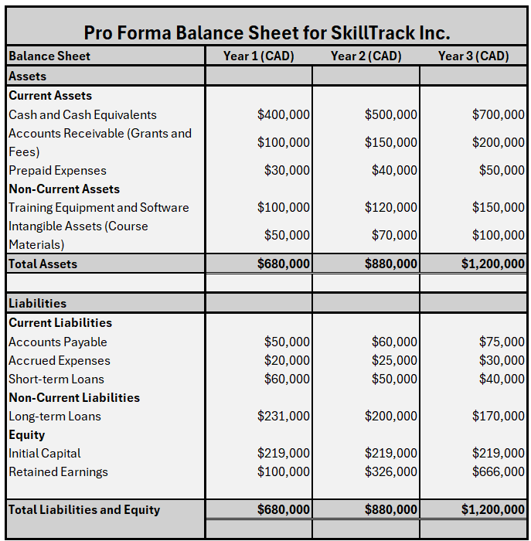
Note. Proforma Balance Sheet of SkillTrack, the figures used in the balance sheet are hypothetical. From Author

Pro Forma Balance Sheet
The Pro Forma Balance Sheet outlines SkillTrack Inc.’s projected financial position over the first three years of operation. It details the company's assets, liabilities, and equity, illustrating its growth and financial sustainability.

Assets:
- Cash and Cash Equivalents:
Cash reserves are expected to grow as profitability increases and cash management improves. Starting with CAD $400,000 in Year 1, cash reserves will rise to $700,000 by Year 3, reflecting the success of SkillTrack's training programs and efficient operational management.
- Accounts Receivable (Grants and Fees):
This reflects pending payments from clients, including both individual trainees and corporate partners. Accounts Receivable is projected to grow from CAD $100,000 in Year 1 to CAD $200,000 by Year 3 as the company increases its customer base and expands its partnerships with businesses and government programs.
- Training Equipment and Software:
Investments in equipment and software are crucial for supporting training delivery. These are expected to increase from CAD $100,000 in Year 1 to CAD $150,000 by Year 3. This growth reflects additional purchases of modern technology and software to improve training effectiveness and keep up with industry trends.
- Intangible Assets (Course Materials):
Course development is a key asset for SkillTrack’s offerings. Intangible assets are projected to rise from CAD $50,000 in Year 1 to CAD $100,000 in Year 3, as the company continues to develop new training materials and courses, expanding its portfolio to attract a wider audience.

Liabilities:
- Current Liabilities (Accounts Payable, Accrued Expenses, Short-term Loans):
- Current liabilities, including accounts payable and accrued expenses, are expected to grow modestly in line with the expansion of operations. From CAD $50,000 in accounts payable and CAD $20,000 in accrued expenses in Year 1, these liabilities will rise to CAD $75,000 and $30,000, respectively, by Year 3.
- Short-term loans will decrease from CAD $60,000 in Year 1 to CAD $40,000 by Year 3, as the company reduces its reliance on short-term debt for operational expenses.
- Non-Current Liabilities (Long-term Loans):
SkillTrack Inc. will leverage the Canada Small Business Financing Program (CSBFP) to secure long-term loans for business expansion. Long-term debt will decrease from CAD $231,000 in Year 1 to CAD $180,000 in Year 3 as the company gradually pays its obligations through stable cash flows.

Equity:
- Initial Capital and Retained Earnings:
The equity section reflects both the founders' initial capital investment and accumulated retained earnings. Initial capital is CAD $219,000, while retained earnings increase from CAD $100,000 in Year 1 to CAD $400,000 in Year 3. This substantial growth in equity is a result of the company’s strong profitability and effective financial management.
- Total Equity:
Total equity, including initial capital and retained earnings, is projected to grow from CAD $319,000 in Year 1 to CAD $885,000 by Year 3. This demonstrates SkillTrack’s financial strength and its ability to generate sustainable profits over the long term.
The financial projections for SkillTrack Inc. illustrate a positive outlook over the next three years. With strong revenue generation from course fees, grants, and controlled operational expenses, the company is expected to achieve healthy profitability and asset growth. By Year 3, SkillTrack will be in a strong financial position, with reduced liabilities, increased equity, and substantial cash reserves, positioning it for long-term success.

